o
[User Documentation: The Great Audio Race]
[Created by: That1Group]
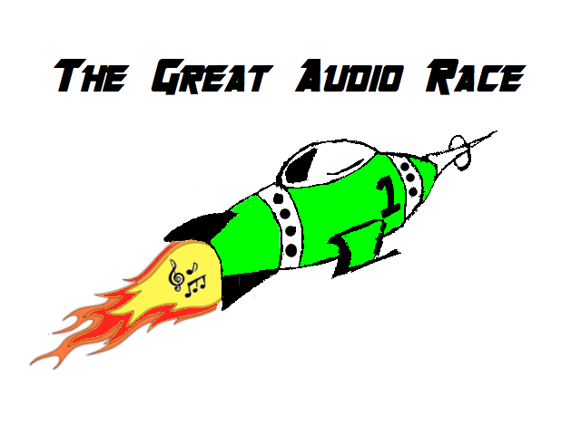
That1Group:
Brandon Scott, Taran Pennebacker, Andrew Rauh, Andrew Lees
Engineering 100.650
The Great Audio Race

Table of Contents
Page 3: System Requirements
Page 4: Main Menu

System Requirements

Not available at this time.

[Main Menu]
Summary:
This is the screen that will be seen originally at the start up of the game. It has four buttons on it that include: Play, Exit, High Scores, and Settings. Each tab leads to a new screen within the game. If the Play button is clicked, the player is brought directly to the screen in-order to begin playing The Great Audio Race. If the High Score button is clicked, the player will be directed to the screen to see all of the top scores of that player on the local machine they are playing on. If the Settings button is clicked, the user will be brought to a screen that allows them to customize the game thoroughly. Finally, if the Exit button is clicked the user will exit from the game.
Detailed Information:
The Main Menu is a file of it’s own that is called upon by the MainGame.py file. When the screen is brought up there are five working and visible options for the user to choose from. They can choose between Settings, Play, High Score, About, and Exit.
As a player clicks the High Scores menu they will be brought to a screen with a list of players that have successfully finished the game along with their score within the game. As the user finishes songs and earns points a top ten list will be provided on the screen. This will include the users initials as well as the score that they received in game.
As the player clicks the Play button then would be brought to a screen that will generate a map based on the song they have selected. They will then begin to the play the game until they have successfully finished the song.
As the player clicks the About button they will be brought to a screen that gives the information about the game. They will be taught about the reasons for the games creation as well as its help in the battle against ASD.
As the player clicks the Settings button they will be brought to a screen with a list of customizable options for them to select from. They can select the difficulty of their game, this being the speed of the game, the amount of obstacles, as well as life total. They can also change the menu colors from the original green color that we have provided for them, and they can also change the color of the rocket ship, changed from the color that is provided at the current time. This will allow for full customization to make the user feel much more comfortable while playing The Great Audio Race.

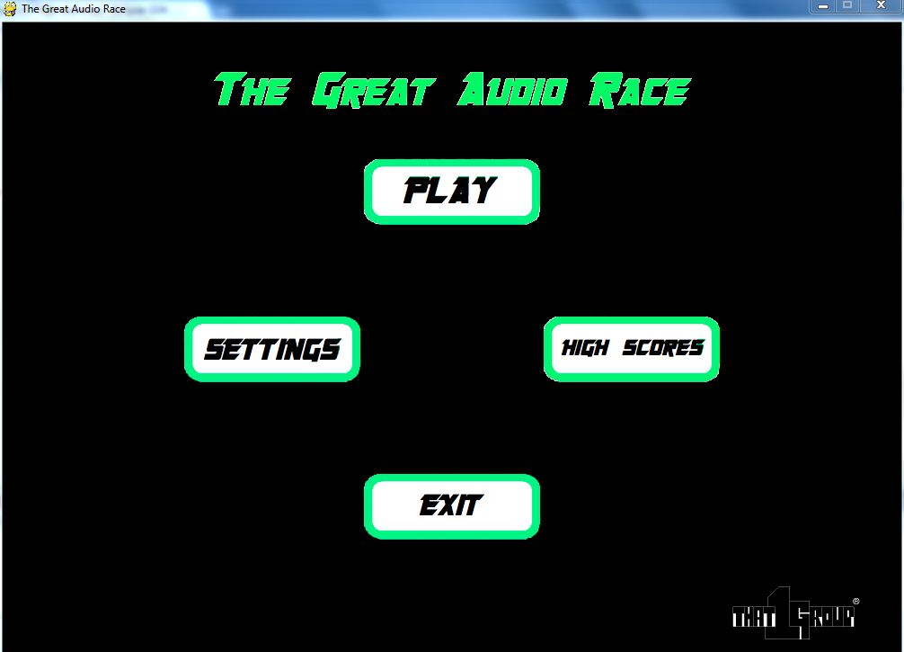
[Current Main Menu screen shot.]

[Background About The Game]
Summary:
This module describes the therapeutic values as well as the goals of our game. The therapeutic values are that the user, usually a patient with ASD, will be able to react and develop the skills needed to react to multiple stimuli simultaneously. Patients that play this game will usually have problems reacting to multiple things that are going on at simultaneous events. With The Great Audio Race they will be able to adhere to attempting to fix this problem by completing the ultimate goal of our game, which is for the patient to receive maximum score on our hardest difficulty with their favorite song.
Detailed Information:
The therapeutic values of this game are to help the user adhere to multiple stimuli at simultaneous times. The game idea sprung from project founder Brandon Scott’s sister. He sat down with his sister and his parents and asked them what they thought was the hardest thing for Regina, his autistic sister, to deal with. They said that she had a hard to reacting to multiple things at one time, especially while she listened to music. Therefore, Brandon thought that a game that incorporated both reaction and music would be very helpful for patients with ASD.
The idea behind the game is that users will have to dodge obstacles and follow a path based on the frequency behind their favorite songs. This will allow them to focus on two things at once both music and collision. The user will react simultaneously to obstacles that generate as well as the math that generates that they can’t see. We as the creators are confident this will help people with ASD attain a much better ability to be able to adapt to situations that they would usually not be able to handle the pressure of overwhelming situations.
The goal of the team is

[High Scores]
Summary:
This module describes the function of the High Scores menu as well as the ability to track a users’ progress based on the difference in scores. The High Scores menu is a basic menu that is used to track the greatest scores achieved by the users while playing the game. These scores can in turn be compared to determine if a specific user is progressing.
Detailed Information:
The High Scores menu will be used to display the highest scores achieved by all users. Each entry will have the users’ initials aligned along the left side of the screen and the corresponding score aligned on the right side of the screen. The scores will be listed in descending order with the highest score at the top of the screen. The ranking of the stored scores will create a competitive nature in the game. The user will always be trying to achieve a greater score and to secure a spot higher in the menu.
The scores that are assigned won’t be specific to each song or difficulty but rather a generalization of both factors. If a song is quick, and the difficulty is set to hard, the user will have more opportunities to gain points. However, if the user selects a harder difficulty, it will be harder to earn the points. This generalization allows for the tracking of progress for a user without the need to repeatedly use the same song or the same difficulty.
The high scores can be used to track the progress of a certain user. By comparing each score that the user receives with the old scores they have obtained, a trend is created on whether the user is adapting to the gaming and progressing. Positive trends suggest that the user is doing well and is able to understand the task at hand while negative trends can signal a lack of understanding. A negative trend doesn’t necessarily mean the user isn’t progressing, a lower difficulty or slower song may be recommended to set a base score.
Each High Scores menu will be localized meaning that the high scores stored in one users’ computer won’t reflect the high scores of another users’ computer. This allows for the tracking of each users progress to be clear and coherent because other scores won’t fill up the spaces on the high scores menu.

